|  |
| --- |
| Team 10 |
| **Compiler Term-Project #1** |
| The implementation of a lexical analyzer |

|  |  |
| --- | --- |
| Date | May 9, 2020 |
| Instructor | Hyosu Kim |
| Team | #10 |
| Members | Heesang Ro (20145001)  Junhyuck Woo (20145337) |



# INDEX

INDEX 1

LEXICAL SPECIFICATIONS 2

TOKENS 3

REGULAR EXPRESSION 4

NFA (Non-deterministic Finite Automata) 5

1. ID 5

2. INTEGER 6

3. FLOAT 8

4. LITERAL 11

DFA (Deterministic Finite Automata) 12

1. ID 12

2. INTEGER 14

3. FLOAT 15

4. LITERAL 17

TROUBLE & SOLUTION 19

1. Longest matching 19

2. Period 20

IMPLEMENTATION 21

1. Definition of Tokens, Alphabet 21

2. ID-DFA 22

3. INTEGER - DFA 23

4. FLOAT - DFA 24

5. LITERAL - DFA 25

6. Other Tokens 26

7. Other - File I/O 27

TEST CASES & RESULT 28

1. Correct Test Code 28

2. Error Test Code 29

APPENDIX 31

1. NFA to DFA with transition table 31

2. Git-Hub 36

# LEXICAL SPECIFICATIONS

|  |
| --- |
| **Variable type**   * int fir a signed integer * char for a literal string * bool for a Boolean string * float for a floating-point umber   **Signed integer**   * A single zero digit * A non-empty sequence of digits, starting from a non-zero digit * A non-empty sequence of digits, starting from a minus sign symbol and a non-zero digit   **Literal string**   * Any combination of digits, English letters, and blanks, starting from and terminating with a symbol “   **Boolean string**: true and false  **Floating-point number**   * A sequence that meets the following conditions:  1. It starts with or without a negative sign symbol 2. . (a decimal point) appears only once 3. Scientific/exponential symbols like E are not allowed 4. Both left and right side of the decimal point must not be empty sequence 5. The left side of a decimal point must be a single digit 0 or a non-empty sequence starting from a non-zero digit 6. The right side of a decimal point must be a single digit 0 or a non-empty sequence terminating with a non-zero digit   **An identifier of variables and functions**   * A non-empty sequence of English letters, digits, and underscore symbols, starting from an English letter or a underscore symbol   **Keywords for special statements**   * if for if statement * else for else statement * while for while-loop statement * for for for-loop statement * return for return statement   **Arithmetic operators**: +, -, *, and /  **Bitwise operator**: <<, >>, &, and |  **Assignment operator**: =  **Comparison operators**: <, >, ==, !=, <=, and >=  **A terminating symbol of statements**: ;  **A pair of symbols for defining area/scope of variables and functions**: { and }  **A pair of symbols for indicating a function/statement**: ( and )  **A symbol for separating input arguments in functions**: ,  **Whitespaces**: a non-empty sequence of \t, \n, and blanks |

# TOKENS

|  |  |
| --- | --- |
| Token | Lexeme |
| VARIABLE | int, float, char, bool |
| KEYWORD | if, else, while, for, return |
| LOGIC | true, false |
| ID | i, j, k, ab_123, func1, func_, __func_bar__, …… |
| INTEGER | 0, 1, 22, 123, 56, -1, -22, -123, -56, …… |
| FLOAT | 0.5, 0.0, -10.0, 100.00001, ,,,,, |
| LITERAL | “Hello world”, “My student id is 12345678”, …… |
| OPERATOR | +, -, *, /, <<, >>, &, | |
| COMPARISON | <, >, ==, !=, <=, >= |
| WHITESPACE | , \t, \n |
| BRACE | {, } |
| PAREN | (, ) |
| ASSIGN | = |
| TERM | ; |
| COMMA | , |

# REGULAR EXPRESSION

Alphabet (Σ)

* A, B, C, D, E, F, G, H, I, J, K, L, M, N, O, P, Q, R, S, T, U, V, W, X, Y, Z, a, b, c, d, e, f, g, h, i, j, k, l, m, n, o, p, q, r, s, t, u, v, w, x, y, z, 0, 1, 2, 3, 4, 5, 6, 7, 8, 9, +, -, *, /, <, &, |, =, ;, , {, }, (, ), ., ,

Symbol

* zero = 0
* non-zero = 1 | 2 | 3 | 4 | 5 | 6 | 7 | 8 | 9
* letter = A | B | C | D | E | F | G | H | I | J | K | L | M | N | O | P | Q | R | S | T | U | V | W | X | Y | Z | a | b | c | d | e | f | g | h | i | j | k | l | m | n | o | p | q | r | s | t | u | v | w | x | y | z

|  |  |
| --- | --- |
| Token | Regular Expression |
| ID |  |
| INTEGER |  |
| FLOAT |  |
| LITERAL |  |
| VARIABLE |  |
| KEYWORD |  |
| LOGIC |  |
| OPERATOR |  |
| COMPARISON |  |
| WHITESPACE |  |
| BRACE |  |
| PAREN |  |
| ASSIGN | = |
| TERM | ; |
| COMMA | , |

# NFA (Non-deterministic Finite Automata)

Our team implemented the NAF (Non-deterministic Finite Automata) with the McNaughton-Yamada-Thompson algorithm. We only handle 4 kinds of tokens, and the other tokens will be implemented as code without a transition table.

## 1. ID

$$\left( letter \right| _ ) {( letter | zero \left| non_zero \right| _ )}^{*}$$

$\left( letter \right| _ )$

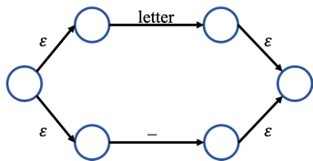

$( letter | zero \left| non_zero \right| _ )$

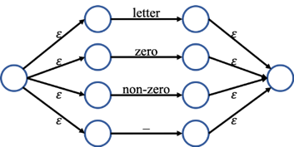

${( letter | zero \left| non_zero \right| _ )}^{*}$

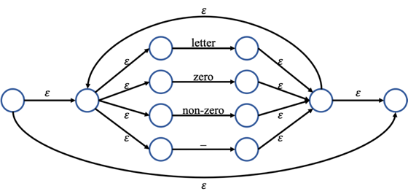

$\left( letter \right| _ ) {( letter | zero \left| non_zero \right| _ )}^{*}$

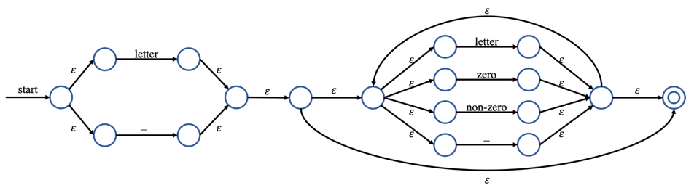

## 2. INTEGER

$$zero | (\left(- | ε\right) non_zero {\left(zero \right| non_zero)}^{*})$$

* $zero$, $non_zero$

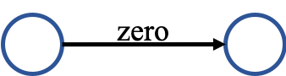 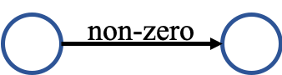

$\left(- | ε\right)$

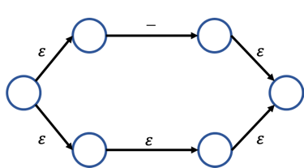

$\left(zero \right| non_zero)$

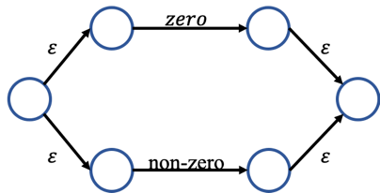

${\left(zero \right| non_zero)}^{*}$

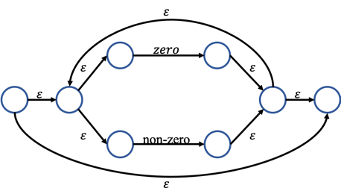

$(\left(- | ε \right) non_zero {\left(zero \right| non_zero)}^{*})$

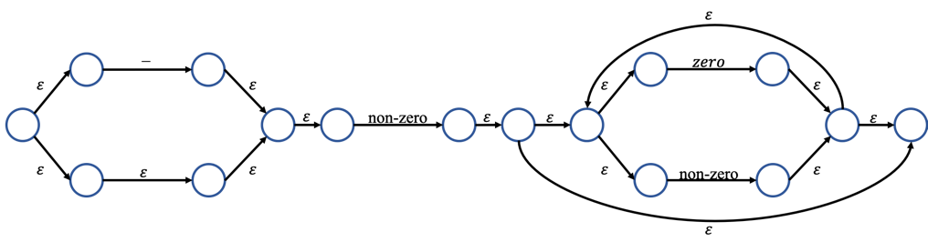

$zero | (\left(- | ε \right) non_zero {\left(zero \right| non_zero)}^{*})$

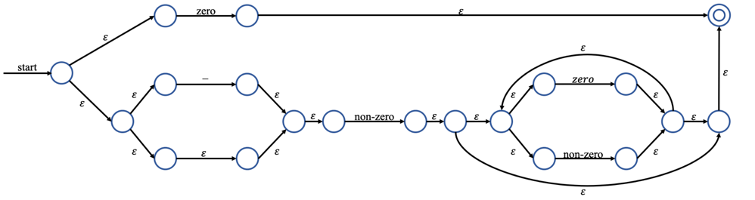

## 3. FLOAT

$$\left(-\right| ε)\left(zero\right|non_zero{\left(zero \right| non_zero)}^{*}) . ( zero|{\left(zero\right|non_zero)}^{*} non_zero )$$

$\left(-\right| ε)$

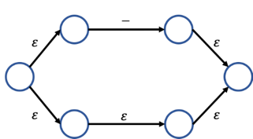

* $zero$, $non_zero,$.

  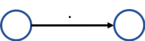

$\left(zero \right| non_zero)$

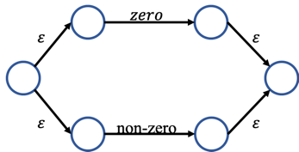

${\left(zero \right| non_zero)}^{*}$



$non_zero{\left(zero \right| non_zero)}^{*}$

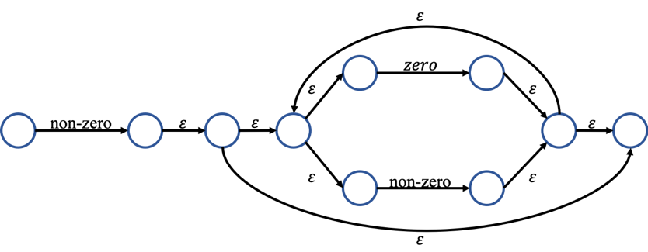

$\left(zero\right|non_zero{\left(zero \right| non_zero)}^{*}$

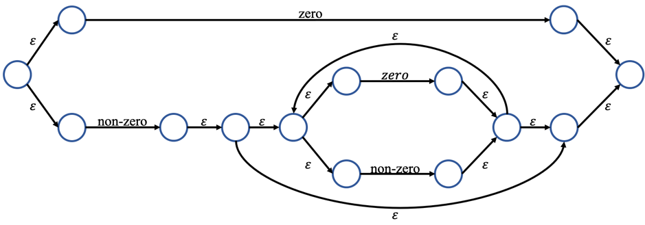

$\left(- \right| ε)\left(zero\right|non_zero{\left(zero \right| non_zero)}^{*})$

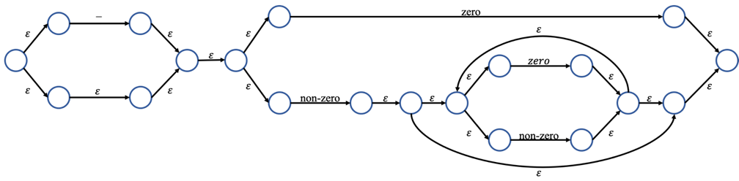

$\left( zero | {\left(zero\right|non_zero)}^{*} non_zero\right)$

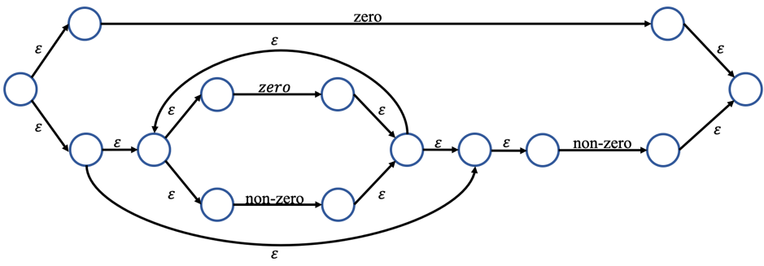

$\left(-\right| ε)\left(zero\right|non_zero{\left(zero \right| non_zero)}^{*}) . ( zero|{\left(zero\right|non_zero)}^{*} non_zero )$

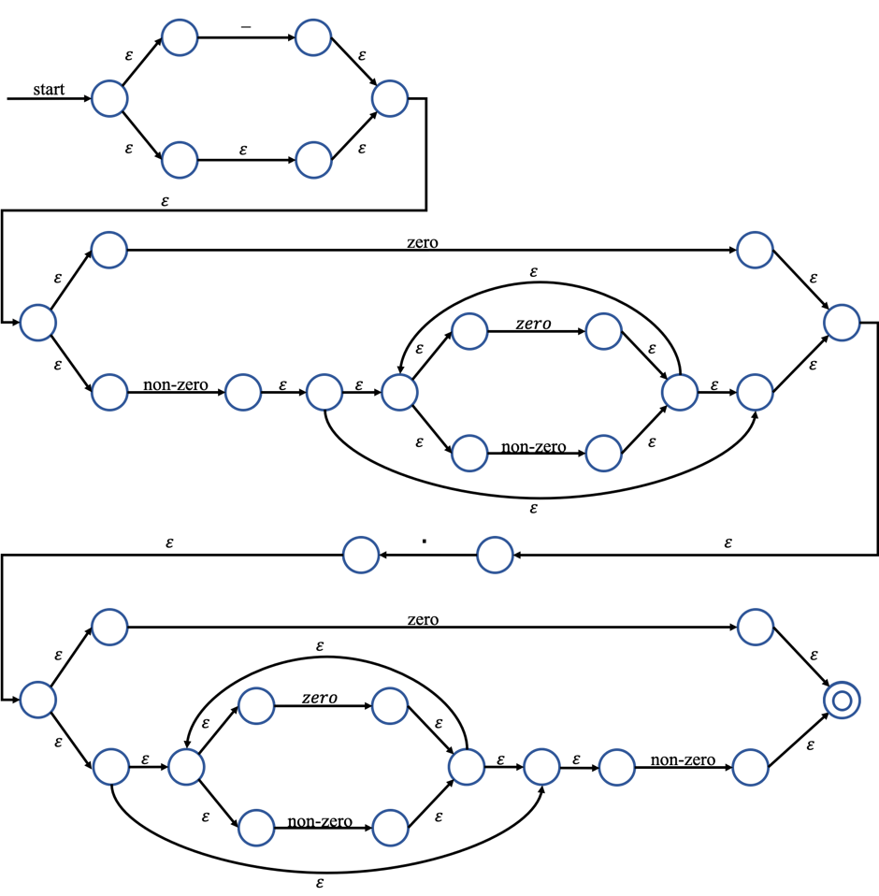

## 4. LITERAL

$$" {\left( letter \right| zero | non-zero | )}^{*} "$$

$"$

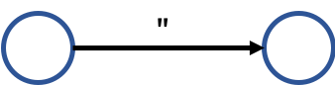

$\left( letter \right| zero | non-zero | )$

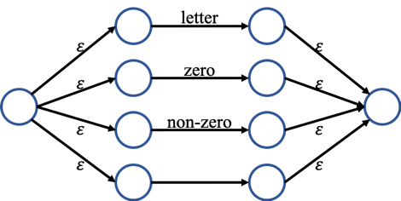

${\left( letter \right| zero | non-zero | )}^{*}$

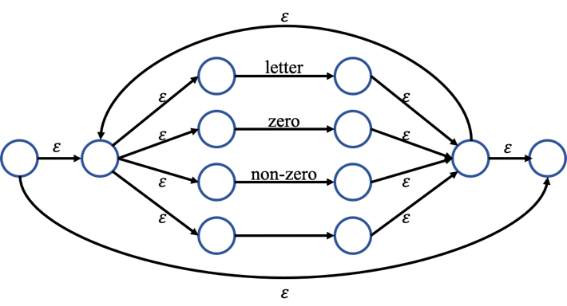

$" {\left( letter \right| zero | non-zero | )}^{*} "$

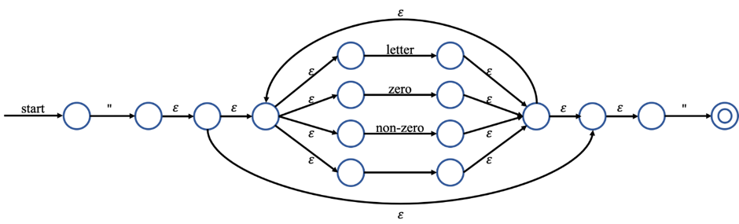

# DFA (Deterministic Finite Automata)

We built DFA graph and transition table using subset (powerset) construction algorithm.

If you want to see the hand-writing paper, please check the appendix 1.

## 1. ID

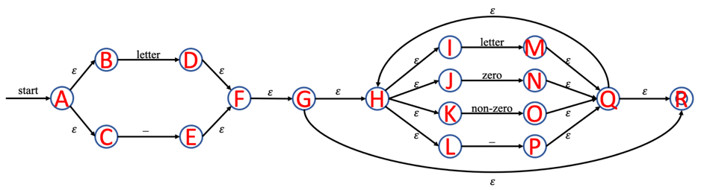

|  |
| --- |
| = {A, B, C} = T0 |
| = = {D, F, G, H, I, J, K, L, R} = T1  =  =  = = {E, F, G, H, I, J, K, L, R} = T2 |
| = = {M, Q, R, H, I, J, K, L} = T3  = = {N, Q, R, H, I, J, K, L} = T4  = = {O, Q, R, H, I, J, K, L} = T5  = = {P, Q, R, H, I, J, K, L} = T6 |
| = = T3  = T4  = = T5  = = T6 |
| = = T3  = T4  = = T5  = = T6 |
| = = T3  = T4  = = T5  = = T6 |
| = = T3  = T4  = = T5  = = T6 |
| = = T3  = T4  = = T5  = = T6 |

* Transition table

|  |  |  |  |  |
| --- | --- | --- | --- | --- |
|  | letter | zero | non-zero | _ |
| * T0 | T1 |  |  | T2 |
| *T1* | T3 | T4 | T5 | T6 |
| *T2* | T3 | T4 | T5 | T6 |
| *T3* | T3 | T4 | T5 | T6 |
| *T4* | T3 | T4 | T5 | T6 |
| *T5* | T3 | T4 | T5 | T6 |
| *T6* | T3 | T4 | T5 | T6 |

* DFA Graph

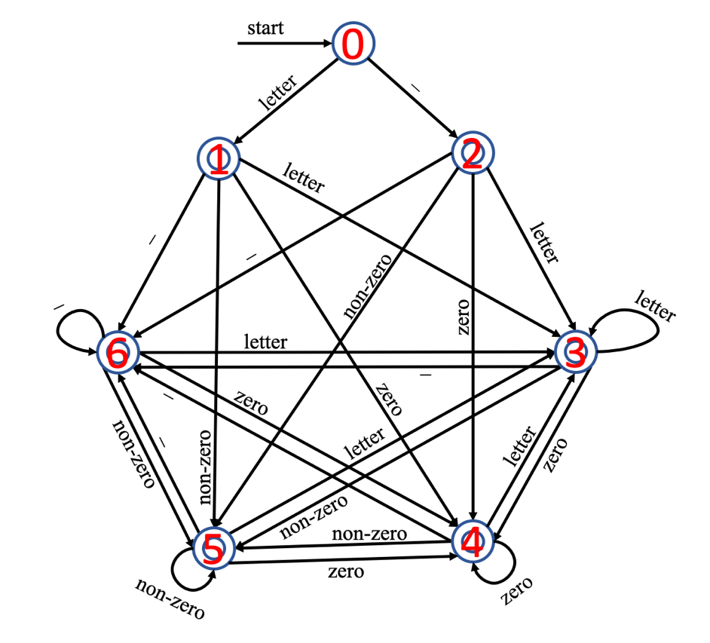

## 2. INTEGER

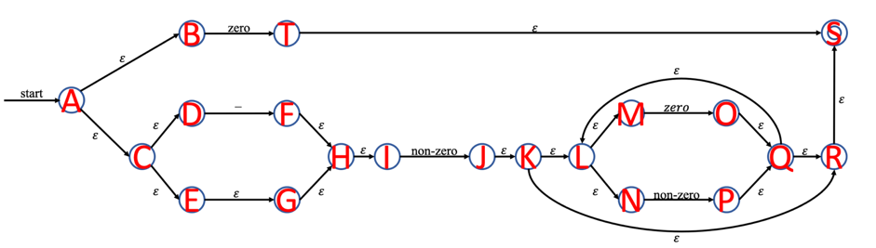

|  |
| --- |
| = {A, B, C, D, E, G, H, I} = T0 |
| = = {F, H, I} = T1  = = {T, S} =T2  = = {J, K, L, M, N, R, S} =T3 |
| =  =  = = T3 |
| =  =  =  = |
| = {O, Q, L, M, N, R, S} = T4  = = {P, Q, L, M, N, R, S} = T5 |
| =  = T4  = = T5 |
| =  = T4  = = T5 |

* DFA Graph
* 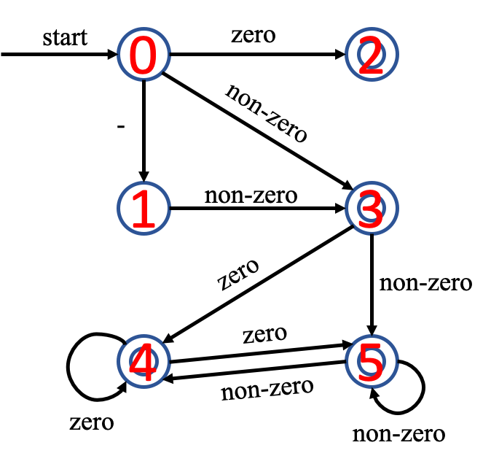Transition table

|  |  |  |  |
| --- | --- | --- | --- |
|  | - | zero | non-zero |
| * T0 | T1 | T2 | T3 |
| T1 |  |  | T3 |
| *T2* |  |  |  |
| *T3* |  | T4 | T5 |
| *T4* |  | T4 | T5 |
| *T5* |  | T4 | T5 |

## 3. FLOAT

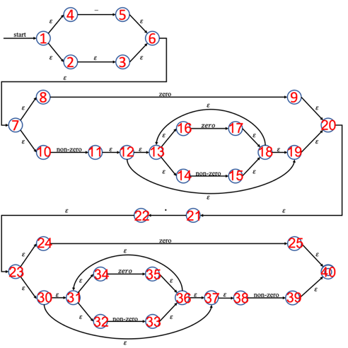

|  |
| --- |
| = {1, 2, 3, 4, 6, 7, 8, 10} = T0 |
| = = {5, 6, 7, 8, 10} = T1  = = {9, 20, 21} =T2  = = {11, 12, 13, 14, 16, 19, 20, 21} =T3  = |
| =  = = T2  = = T3  = |
| =  =  =  = = {22, 23, 24, 30, 31, 32, 34, 37, 38} = T4 |
| =  = {13, 14, 15, 16, 18, 19, 20, 21} = T5  = {13, 14, 16, 17, 18, 19, 20, 21} = T6  = = T4 |
| =  = {25, 31, 32, 33, 34, 36, 37, 38, 40} = T7  = = {31, 32, 34, 35, 36, 37, 38, 39, 40} = T8  = |
| =  = T5  = = T6  = = T4 |
| =  = T5  = = T6  = = T4  = |

= {31, 32, 33, 34, 36, 37, 38} = T9

|  |
| --- |
| = = T8  = |
| =  = T9  = = T8  = |
| =  = T9  = = T8  = |

* Transition table

|  |  |  |  |  |
| --- | --- | --- | --- | --- |
|  | - | zero | . | non-zero |
| * T0 | T1 | T2 |  | T3 |
| T1 |  | T2 |  | T3 |
| T2 |  |  | T4 |  |
| T3 |  | T5 | T4 | T6 |
| T4 |  | T7 |  | T8 |
| T5 |  | T5 | T4 | T6 |
| T6 |  | T5 | T4 | T6 |
| T7 |  | T9 |  | T8 |
| T8 |  | T9 |  | T8 |
| T9 |  | T9 |  | T8 |

* DFA Graph

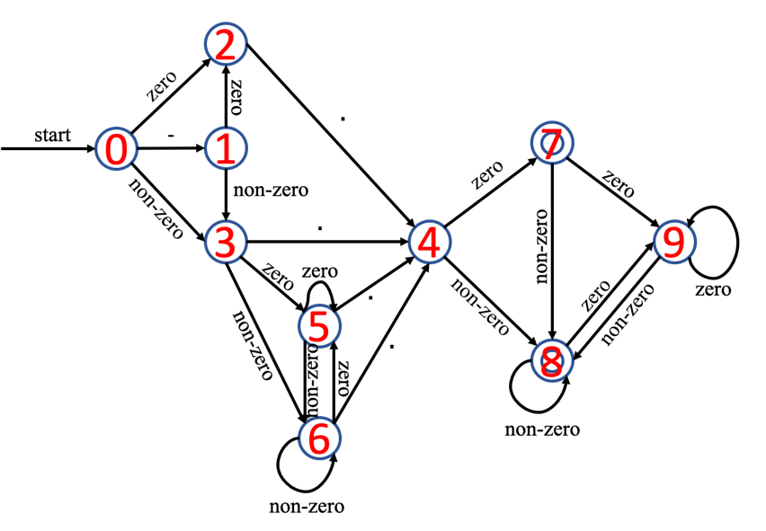

## 4. LITERAL

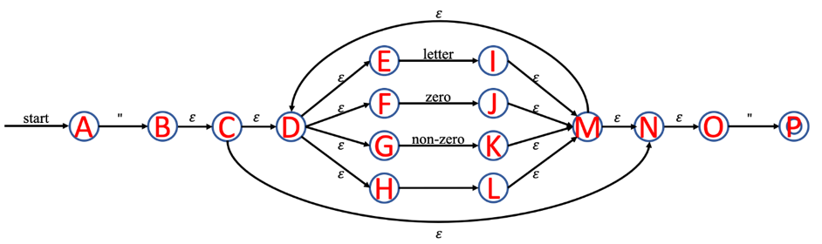

|  |
| --- |
| = {A} = T0 |
| = = {B, C, D, E, F, G, H, N, O} = T1  =  =  =  = |
| = = {P} = T2  = = {I, M, N, O, D, E, F, G, H} = T3  = = {J, M, N, O, D, E, F, G, H} = T4  = = {K, M, N, O, D, E, F, G, H} = T5  = = {L, M, N, O, D, E, F, G, H} = T6 |
| =  =  =  =  = |
| = = T2  = = T3  = T4  = = T5  = = T6 |
| = = T2  = = T3  = T4  = = T5  = = T6 |
| = = T2  = = T3  = T4  = = T5  = = T6 |
| = = T2  = = T3  = T4  = = T5  = = T6 |

* Transition table

|  |  |  |  |  |  |
| --- | --- | --- | --- | --- | --- |
|  | “ | letter | zero | non-zero |  |
| * T0 | T1 |  |  |  |  |
| T1 | T2 | T3 | T4 | T5 | T6 |
| *T2* |  |  |  |  |  |
| T3 | T2 | T3 | T4 | T5 | T6 |
| T4 | T2 | T3 | T4 | T5 | T6 |
| T5 | T2 | T3 | T4 | T5 | T6 |
| T6 | T2 | T3 | T4 | T5 | T6 |

* DFA Graph

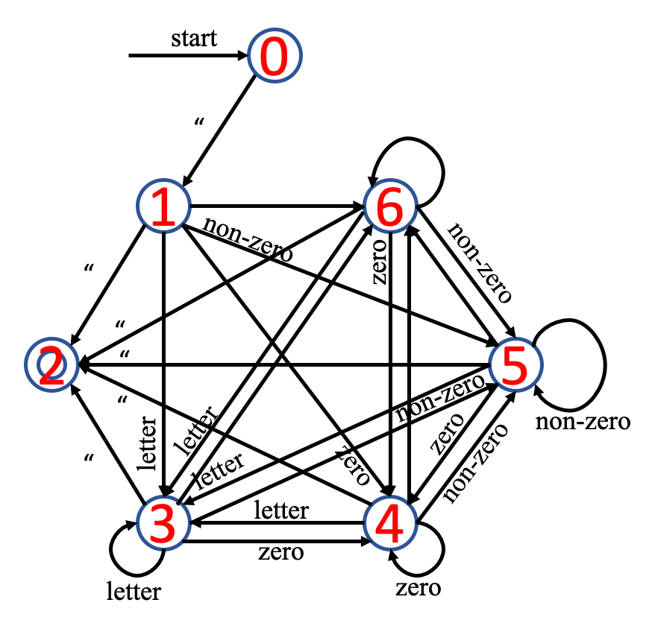

# TROUBLE & SOLUTION

## 1. Longest matching

* Trouble

When we tested identifier that includes keyword and variable (e.g. if, while, int, char), longest matching didn’t work well.

|  |  |  |
| --- | --- | --- |
| Input | Expected result | Result |
|  | ……  VARIABLE int  ID int_ABC  ASSIGN =  …… | ……    …… |

* Solution

We add more if condition in variable, keyword, logic part so that our program can do longest matching.

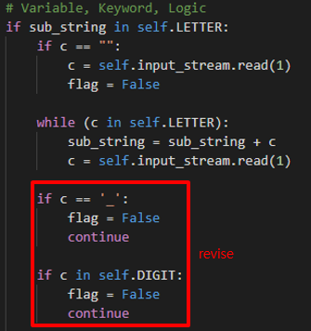

* Result

|  |  |  |
| --- | --- | --- |
| Input | Previous result | Revised result |
|  | ……    …… |  |

## 2. Period

* Trouble

When we tested . (Period) without any prefix, our program is finished that line.

|  |  |  |
| --- | --- | --- |
| Input | Expected result | Result |
|  | Line2 error! | Program is finished unexpected. |

* Solution

At first, our program didn’t include the condition that what we did if the first substring is . (Period). So, we add . (Period) condition in our program.



* Result

|  |  |  |
| --- | --- | --- |
| Input | Previous result | Revised result |
|  | Program is finished unexpected. |  |

# IMPLEMENTATION

Before explaining our works, we will introduce the developing environment and how to manage our project, please check the appendix-2.

|  |
| --- |
| **Language**   * Python3 (version: 3.7.4)   **Operating System**   * macOS Catalina * Windows 10   **IDE (Integrated Development Environment)**   * Visual Studio Code (version: 1.45.0) * PyCharm (version: 3.9.4)   **Project Management**   * Git (version: 2.24.2) * Git-Hub |

We defined the four tokens: ID, INTEGER, FLOAT, LITERAL as function, and the others are defined as a list type variable. In addition, we defined five symbols; LETTER, SYMBOL, ZERO, NON_ZERO and DIGIT to improve the productivity and readability.

## 1. Definition of Tokens, Alphabet

We defined the four tokens: ID, INTEGER, FLOAT, LITERAL as function, and the others are defined as a list type variable. In addition, we defined five symbols; LETTER, SYMBOL, ZERO, NON_ZERO and DIGIT to improve the productivity and readability.

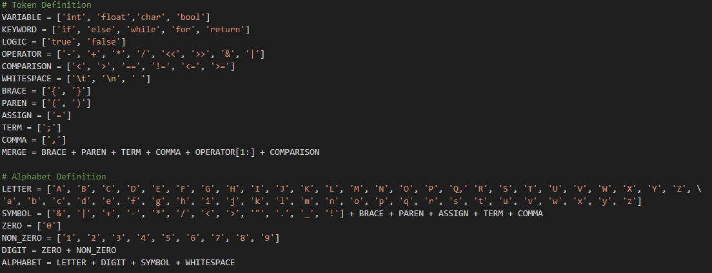

## 2. ID-DFA

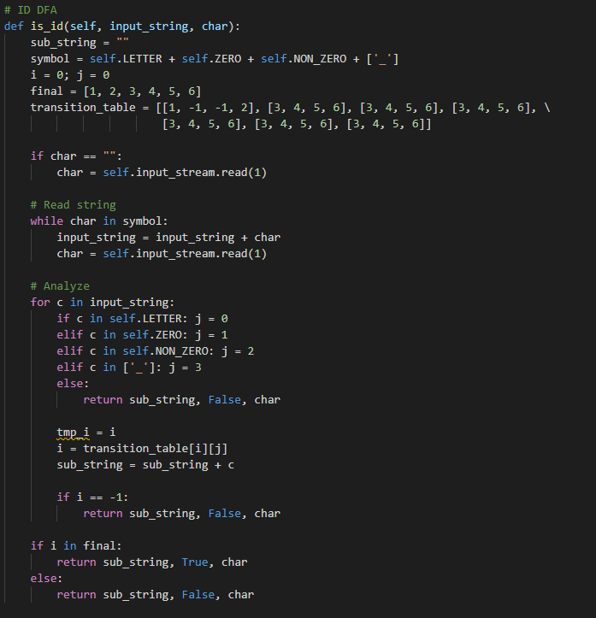

This part of code is for ID DFA that decides whether the input_string is ID or not. This method has 7 states, and the start state is 0. In a for-loop, it works exactly the same as the ID DFA that was designed in the previous page. This method reads input_string in order, and a recent state is changed by input_string. If it is finished in the final states, which are 1 to 6, the input_string will be accepted. Otherwise, the input_string will be denied, and it means the input_string isn’t ID.

## 3. INTEGER - DFA

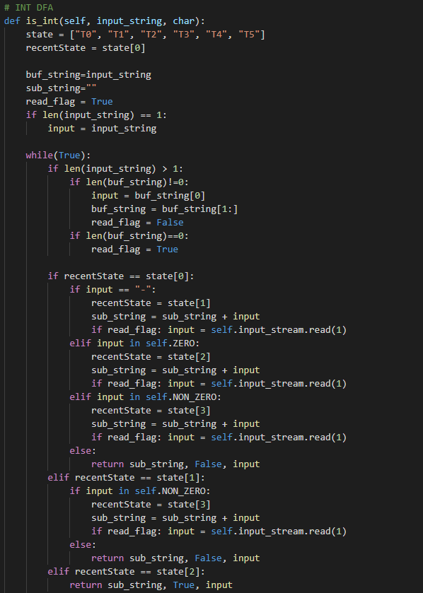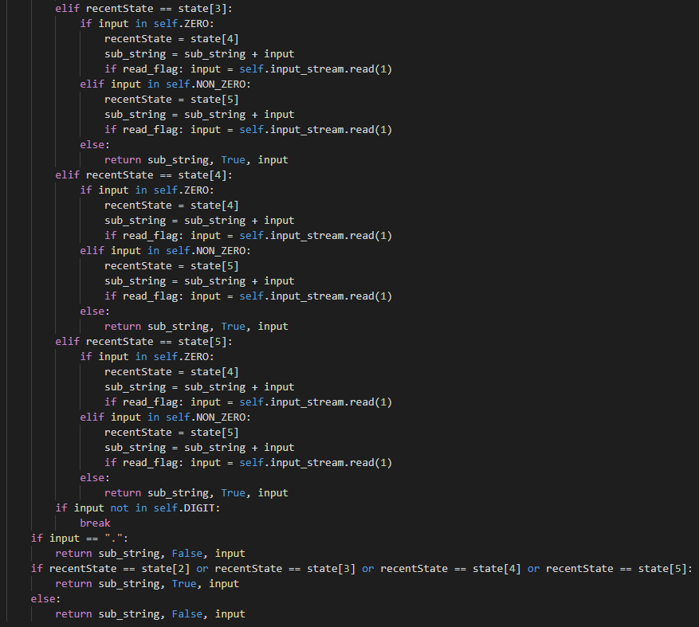

This part of code is for INT DFA that decides whether the input_string is int or not. This method has 6 states, and the start state is T0. In a for-loop, it works exactly the same as the INT DFA that was designed in the previous page. This method reads input_string in order, and a recent state is changed by input_string. If it is finished in the final states, which are state2, state3, state4, and state5, the input_string will be accepted. Otherwise, the input_string will be denied, and it means input_string isn’t int.

## 4. FLOAT - DFA

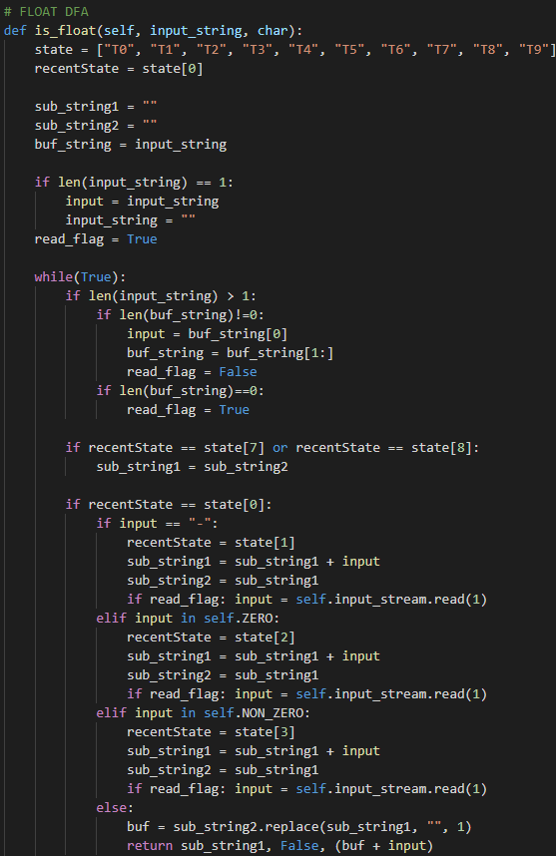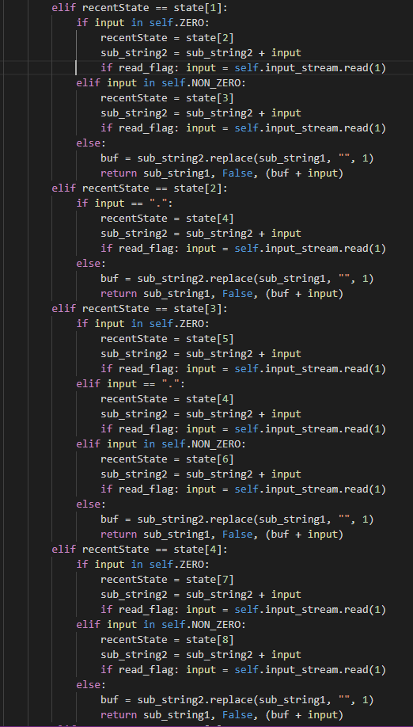

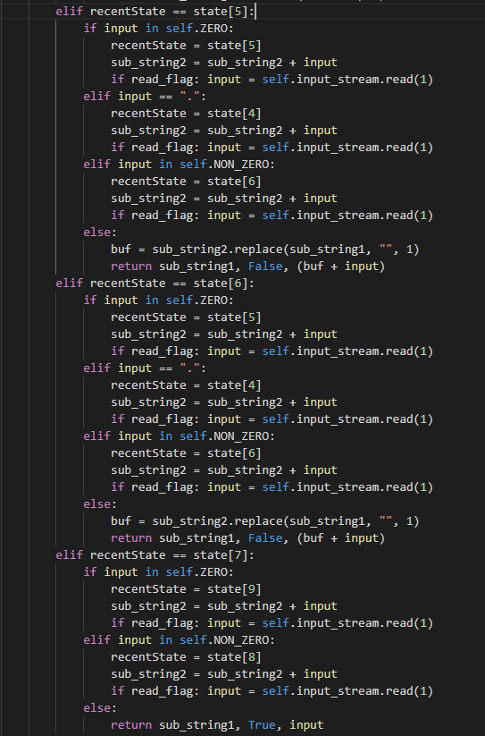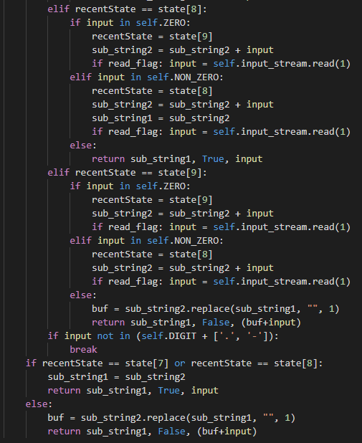

This part of the code is for FLOAT DFA that decides whether the input_string is float or not. This method has 10 states, and the start state is T0. In a for-loop, it works exactly the same as the FLOAT DFA that was designed in the previous page. This method reads input_string in order, and a recent state is changed by input_string. If it is finished in the final states, which are state7 and state8, the input_string will be accepted. Otherwise, the input_string will be denied, and it means input_string isn’t a float.

## 5. LITERAL - DFA

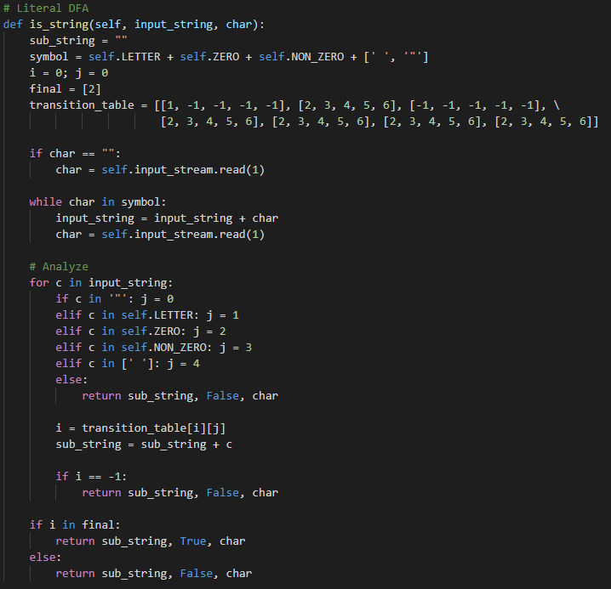

This part of code is for LITERAL DFA that decides whether the input_string is a string or not. This method has 7 states, and the start state is 0. In a for-loop, it works exactly the same as the LITERAL DFA that was designed in the previous page. This method reads input_string in order, and a recent state is changed by input_string. If it is finished in the final state, which is 2, the input_string will be accepted. Otherwise, the input_string will be denied, and it means input_string isn’t a string.

## 6. Other Tokens

The software checks the other tokens following matching processing.

|  |  |
| --- | --- |
| * Variable, Keyword, Logic      * ASSIGN, COMPARISON    | * BRACE, PAREN, TERM, COMMA, OPERATOR, COMPARISON    |

* Subtract

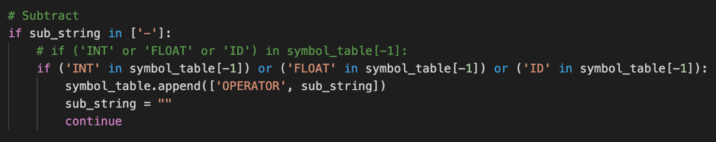

## 7. Other - File I/O

* Read File

|  |  |
| --- | --- |
|  |  |

* Write File

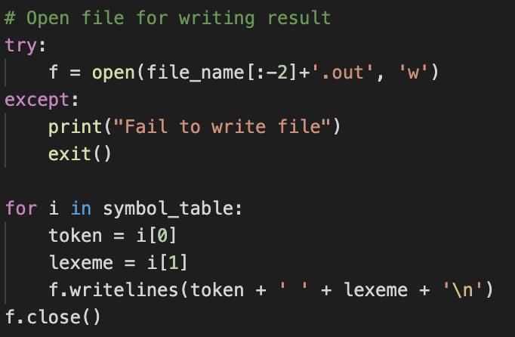

* Error Case

If the code is written as out of correct grammar, the software returns the error message and creates the error message file as followed format FIEL_NAME_error.out. There are 5 points where check the error; each of them use the same code, so we attached a single picture.

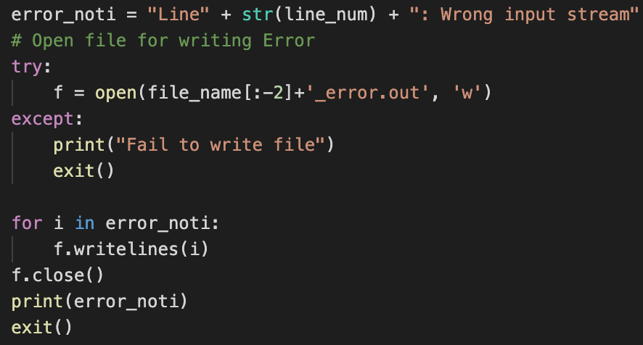

# TEST CASES & RESULT

## 1. Correct Test Code

|  |  |
| --- | --- |
| **Input** | **Result** |
|  |  |

## 2. Error Test Code

* In our lexical analyzer, we don’t allow to use the character ‘$’.

|  |  |
| --- | --- |
| **Input** | **Result** |
|  |  |

* ‘=!’ isn’t correct comparison.

|  |  |
| --- | --- |
| **Input** | **Result** |
|  |  |

* ‘.0’ isn’t correct float.

|  |  |
| --- | --- |
| **Input** | **Result** |
|  |  |

* ‘a.a’ isn’t correct input.

|  |  |
| --- | --- |
| **Input** | **Result** |
|  |  |

* Literal string should be terminated with a symbol “.

|  |  |
| --- | --- |
| **Input** | **Result** |
|  |  |

# APPENDIX

## 1. NFA to DFA with transition table

* ID

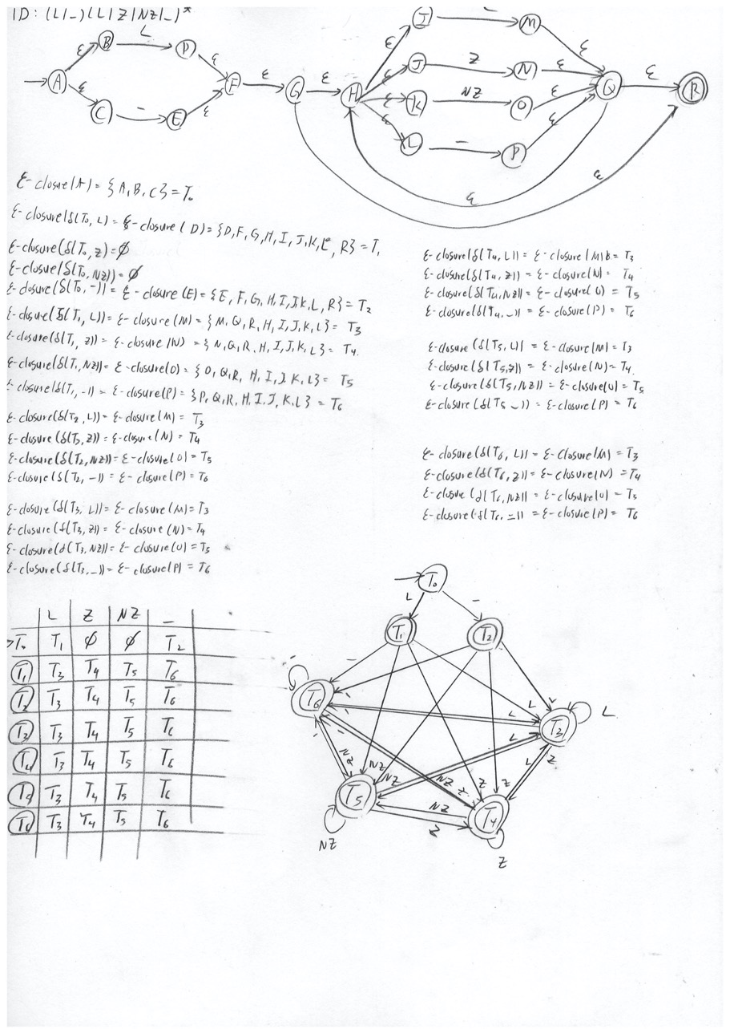

* INTEGER

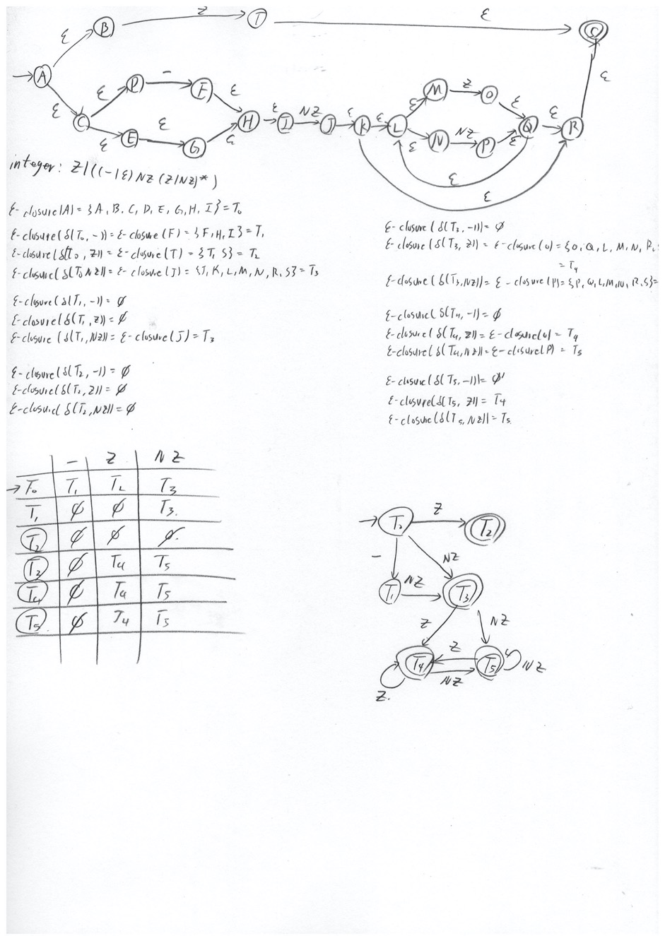

* FLOAT

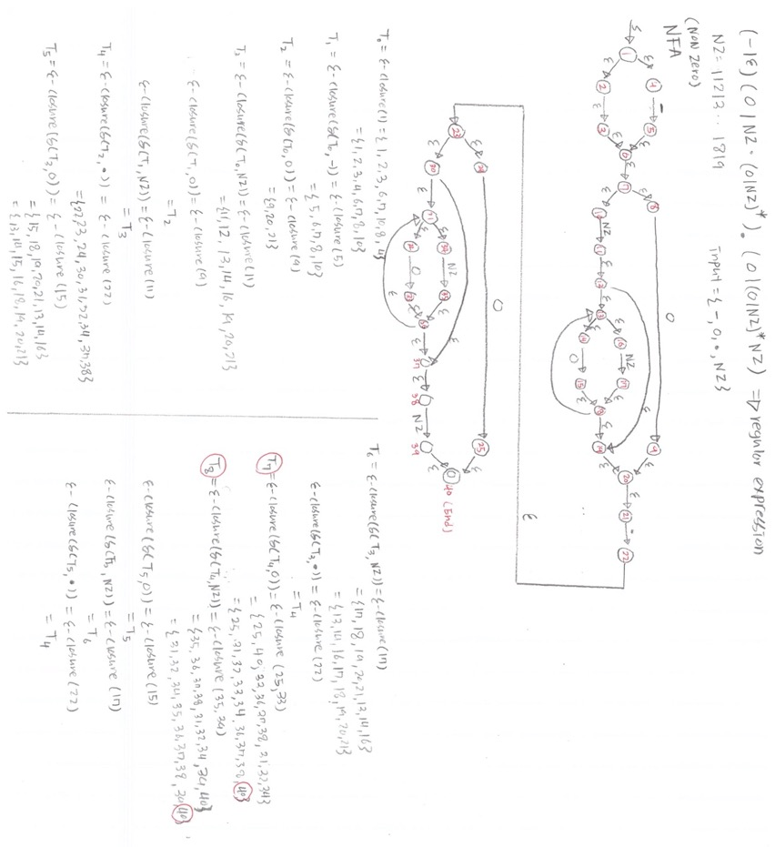

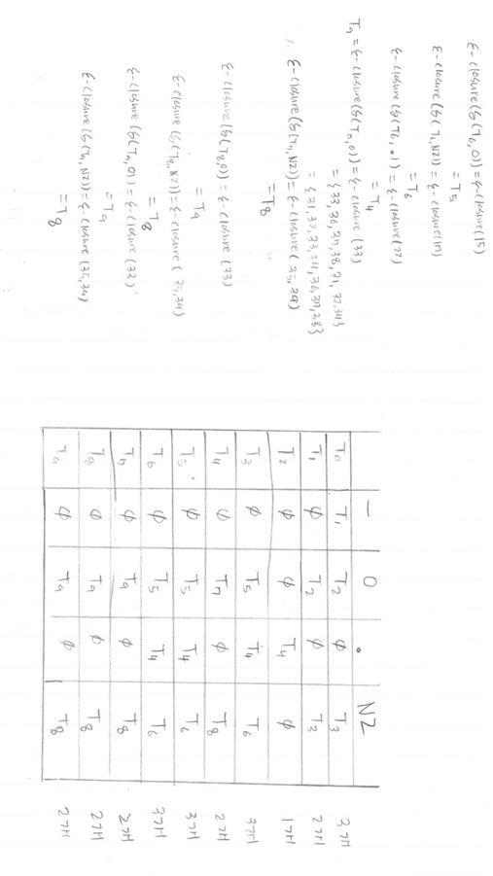

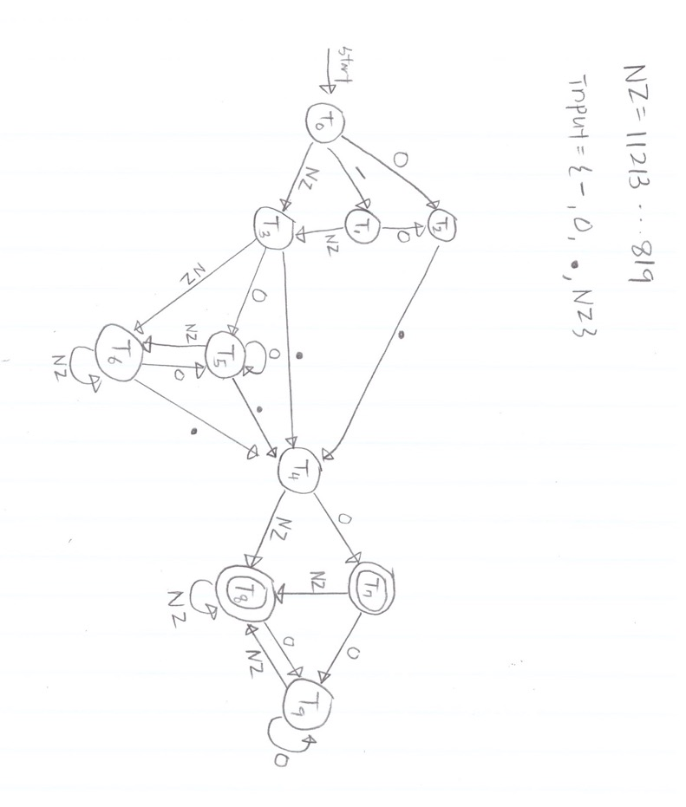

* LITERAL

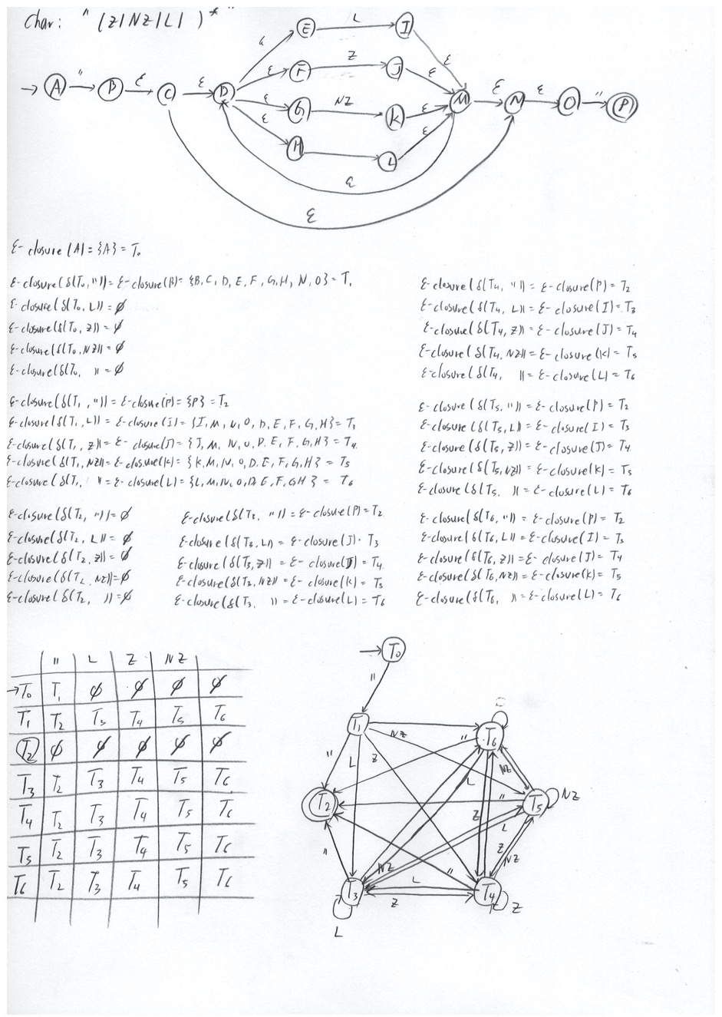

## 2. Git-Hub

* Project Overview

* Projects Management

